JMP web service design notes (Ver 2.2.0)

Date: 10.01.2021

|  |  |  |
| --- | --- | --- |
| Ver. | changes | date |
| 2.0.0 | Changes in all aspects – process flow and functionality | 10.01.2021 |
| 2.2.0 | Changes marked in green  REQ_ID – cancel validation | 28.02.2021 |

# Objectives

* Enable using pre-defined JMP modules (in Python code), for calculating estimated cost or partial cost , while running SAP quotation (VA22) or other
* Process will support changes in the modules calculation , and using different modules - based on pre-determined attributes

# Process steps

**Step 1** – temporary quick solution *

Create dedicated Tcode with the following functionality

* User will select a Module name from dedicated Z_table
* Relevant material characteristics will be available according to the Z_table mapping

Example: (file attached)

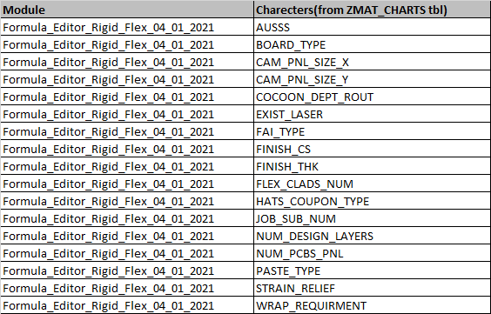



* The program will copy all relevant material characteristics
* User will set values from each character, from a close list of values (inc. in ), strings only, integers/floats can be manually override.
* User will post a request to the WS with the selected Parameters + req_id + model name (see example in paragraph 3)
* Note – it is mandatory to fill all the associated characters with values , in order to post the request

**Step 2** – the event will call a web service in the follwing path :

* + <http://websrvdev-01.pcb-il.co.il:5001/jmp/> (DEV & TESTING)
  + <http://websrvprd-01.pcb-il.co.il:5001/jmp/> (PRD*)

sending relevant parameters, in a JSON format.

**Step 4** – A local REST web service, will handle the JMP’s formula files,

* + receiving the SAP “POST” with JSON data
  + validating data
  + Assigning it to the relevant module & function
  + “POST” back the returned result in a JSON format

**Step 5** – temporary quick solution

* The program will collect all the parameters and values that were send + the WS answer values, and introduce it to the user screen

# 3. The WS functionality & rules:

1. The WS expect t get a request (POST)in JSON Array format, in the message body :

{

 "REQ_ID":"I3333333",

 "SAP_ITEM_CHARECTERISTIC_1" : Value(str,Float),

 "SAP_ITEM_CHARECTERISTIC_2" : Value(str,Float),

 "SAP_ITEM_CHARECTERISTIC_3" : Value(str,Float)

  …more ,

}

The messege will include all the valuess relevant for the chosen module (paragraph 2), attached example for the JSON structore

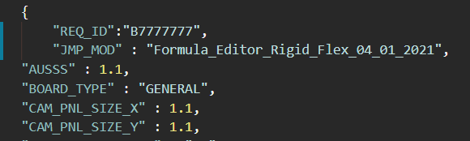



1. ~~REQ_ID – messege will include is identifier for the request and it is unique fo~~*~~r qoute_no &qoute_line_no~~*

~~REQ_ID format include digits, the last digit is a key validation- includes the average of all the digits - rounded down. no length limit.~~

~~In case the REQ_ID, from some reason, does include non-digit characters, the base format still applies (the program will consider only the digits in the string for the calculation).~~

Not Valid in this ver. ,there is no need anymore , as now the program validate the requested module name

1. The WS will validate that the ‘module name’ exist in its internal modules pull (python modules files that maintained in a dedicated folder, see Maintanance paragraph).

If exits the WS will valdate all characteristic exist in the post request

If one of the parameters is missing, expect to get the following message



If the module details doesn’t exist



Note – JMP_result: 999999, inducate problem in calculation, the Message will indicate the problem

1. WS will run the relevant function in the selected module and return results in a JSON format , see example (param are as the one in the JSON file example, for quick simulation) :

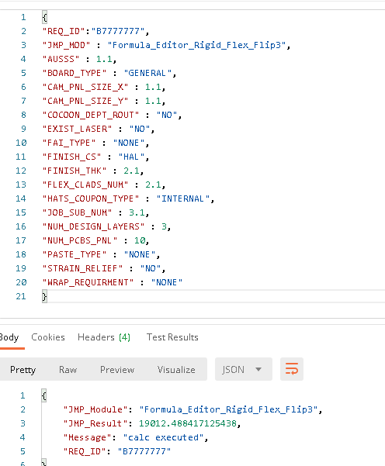

5. Versions & supported modules:

Use the relative URL (…/jmp/module) to determine the app version and loaded modules

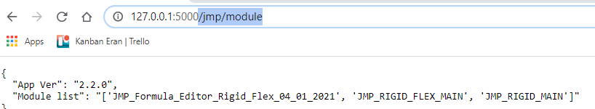

# 4. Maintanance -Loading new JMP modules:

1. The new JMP files (Python format) need to be named with a “JMP” prefix and a “.py” extension (example: JMP_RIGID_FLEX.py)
2. The files need to be set at the “pkg” directory in the app root (example: “\\JMPapp\pkg\” )
3. After setting a new JMP module file or replacing an old one, the ‘JMPApp’ service need to be restarted, in order for the changes to take place

sudo systemctl stop jmp01

sudo systemctl start jmp01

sudo systemctl enable jmp01